Step 1

Step 2

Step 3

Step 4

Step 5

This type of data is put into tables**. Table data** is the data format.

Step 6

The operation above has no results because the program is not able to find any data associated with the specific data types mentioned for those columns. The data types mentioned in the code are incorrect.

Step 7

Step 8

Step 9

Step 10

The data type for id is BIGINT instead of INT or SMALLINT because the data **is 8-byte signed integers.** SMALLINT is a 2-byte signed integer and INT is a 4-byte signed integer, so they are not suitable.

Step 11

Step 12

Step 13

We are using **sqoop import** tool here. We are getting our data and putting it into HDFS.

Step 14

Yes, I do see the device folder in the Metastore. The second picture displays the contents in the device folder.

Step 15

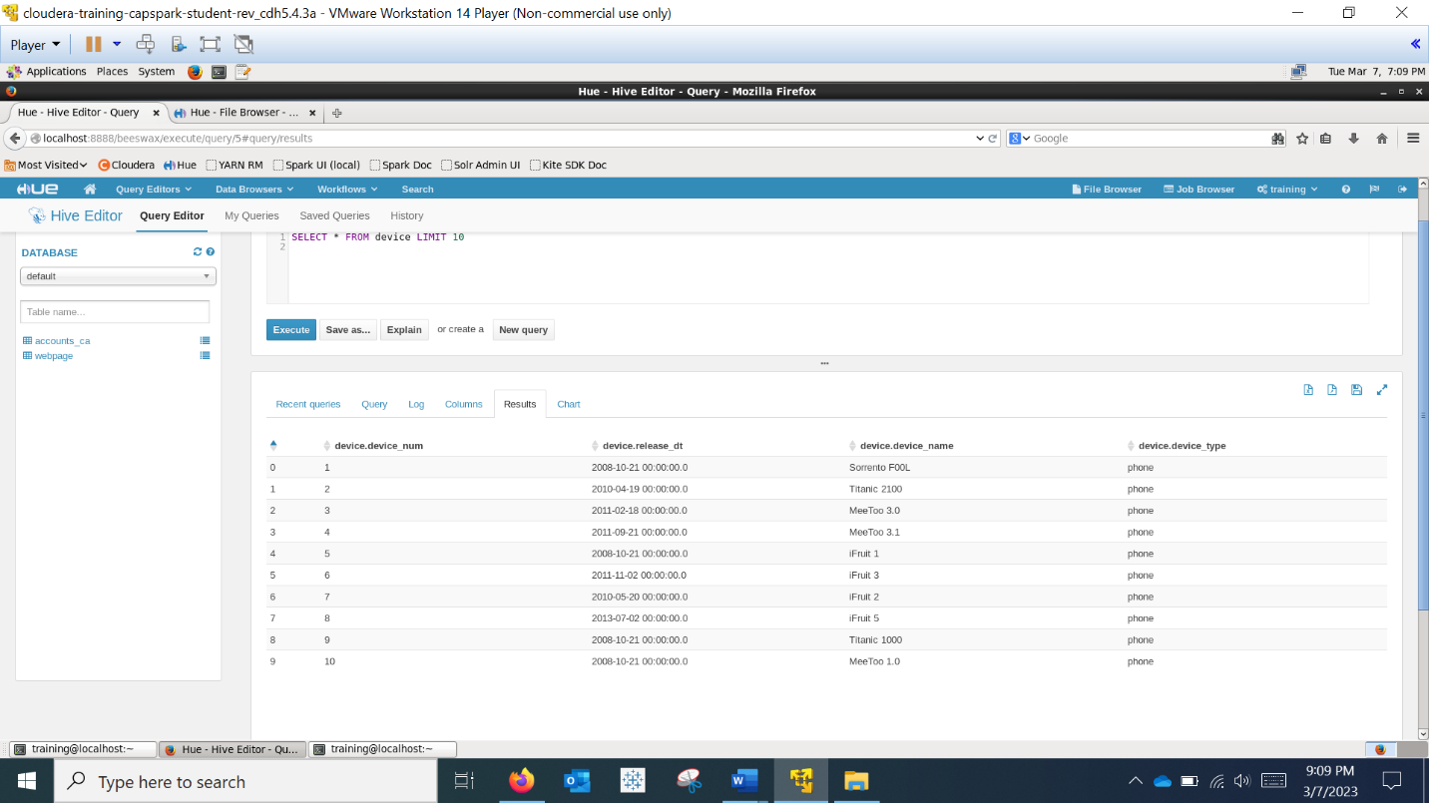

Step 17

Step 18

Step 19

Step 20

